Physics WoF Diagnostic 2016 Name:______________________

The following questions will assess your skill in several areas that will be essential to your success in Physics this year. Answer as many questions as you can and make note of areas that you may need to refresh.
Grade:

Fill in the blanks for the following tables
(5 pts)
(3 pts)
(2 pts)
(3 pts)

- Convert the following quantities, show working and units (5 pts)

6 foot 3 inches into cm (2.54 cm = 1 in) 365,000 seconds into days

Solve with your calculator with appropriate significant figures (5 pts)

1.05x10⁻²⁶ = (3.5x10³)(6.45x10¹⁰)(3.498x10⁻⁷) =
4.2x10⁵⁶

Solve for x and show all working (5 pts)

5x - 7 = 11 3(x-5) = 12

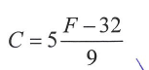
The formula to convert Fahrenheit temperatures to Celsius is

What is the temperature in Celsius (ºC) when it is 50 ºF?

(3 pts)

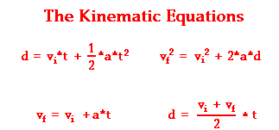
Choose an equation and solve for d:
(show full working)

vi = 8 m/s
vf = 0
t = 12 s

(3 pts)

Rearrange the following equations and solve for the letter in bold, show working (10 pts)
