**Scholarship Level Score /8**

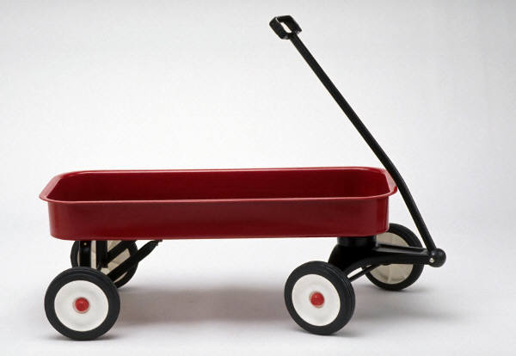1) A trolley rolls along a smooth surface at constant velocity.

* Harry pours a bucket of sand in vertically onto the trolley.
* The sand then dribbles out a hole in the bottom.

Explain how the velocity changes [2]



2) A chain hangs over a smooth table a shown.

Explain how the acceleration changes as it slides off. [1]



3) A sailor climbs her mast by pulling herself up using a rope and pulley as shown. If she is 60 kg, how much force must she exert to rise at a constant velocity of 1.0 ms-1. [1]

1. A 150g hover disc collides with an identical hoverdisc and rebounds as shown. The collision lasts 0.0015 s.

450

2.0 ms-1

1.0 ms-1

* 1. Calculate the average force on the **white** disc during the collision. [1]

* 1. Calculate the momentum of the **centre of mass** after the collision. [1]

5.0 kg

3.0 kg

530

370

150 ms-1

200 ms-1

1. A 15 kg bomb moving at 12 ms-1 North explodes into three pieces as shown.

Calculate the velocity of the third piece. [2]

**Scholarship Level Solutions**

1) A trolley rolls along a smooth surface at constant velocity.

* Harry pours a bucket of sand in vertically onto the trolley.
* The sand then dribbles out a hole in the bottom.

Explain how the velocity changes

*Solution 1)- in terms of Momentum being conserved (no outside forces).*

* *The trolley has some horizontal momentum, the sand has no horizontal momentum.*

*When the sand lands on the trolley, the sand speeds up (gains momentum) the trolley slows down (loses momentum).* ***The trolley velocity decreases****.*

* *When the sand flows out, it is still moving forward at the same speed, its momentum doesn’t change so the trolley’s momentum won’t change.*

*Solution 2) in terms of Forces*

* *Trolley exerts a forward force on the sand, so Sand exerts an equal and opposite force on the trolley (slowing it down)*
* *When it falls out, trolley exerts no force on sand so sand exerts no force on trolley (velocity won’t change)*

2) A chain hangs over a smooth table a shown.

Explain how the acceleration **changes** as it slides off.

*As it slides off, there is more unsupported chain so the accelerating force increases so the acceleration increases a= F/m (constant mass)*

*Algebraically… a= Mg / (M+m)*

*Where M is hanging chain mass and m is remaining chain mass*

*As chain slides off table, M ↑ while m↓ so equation M/(M+m) goes to 1 and a = g*

1. A sailor climbs her mast by pulling herself up using a rope and pulley as shown. If she is 60 kg, how much force must she exert to rise at a constant velocity of 1.0 ms-1.

*She is not accelerating, so the net force on her is zero.*

*Gravity force is 600 N, so tension must be 600 N, each rope produces 300 N, so she exerts 300N force on rope.*

*This does not contravene energy conservation. (W = F x d)*

*She only applies 300N force but this force moves twice the distance she moves.*

450

2.0 ms-1

1.0 ms-1

1. A 150g hover disc collides with an identical hoverdisc and rebounds as shown. The collision lasts 0.015 s.
2. Calculate the average force on the **white** disc during the collision.

Using cosine rule, Δp = 0.22 kgms-1



45o

.15 kgms-1

.30 kgms-1

Δp

So F= 147 N

1. Calculate the momentum of the **centre of mass** after the collision.

Same as momentum of the **centre of mass** before the collision.

Which is same as total momentum before the collision.

P= 0.30 kgms-1

1. A 15 kg bomb moving at 12 ms-1 North explodes into three pieces as shown. Calculate the velocity of the third piece.

5.0 kg

3.0 kg

530

370

150 ms-1

200 ms-1

Total final momentum = Total initial momentum = 180 kgms-1 N

**By components**, total final momentum of the two pieces is: 930 N and 240 W

So third piece must have 750 S and 240 E

P= 787 kgms-1.

So v= 787/7 = 110 ms-1.

IN class

Calculate the tension force acting on the 80 kg climber.

The angle between the rope and the cliff is 200.

The angle between the climber and the cliff is 500

Assume the rope is attached to his center of mass which is half way between is head and feet.

(hint consider torques about his feet)



Hence calculate the vertical force on his feet

