SEWING MACHINE
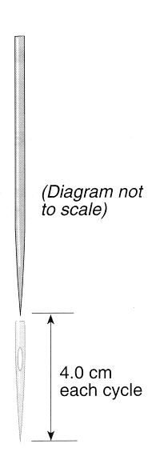
The needle of a sewing machine oscillates in simple harmonic motion, SHM. The needle travels 4.0cm up and 4.0cm down each cycle, as shown in the diagram. The machinist operates the machine so that the needle moves at 1600 cycles per minute.

- Calculate the following quantities for the motion of the needle.

  - Amplitude in metres.

  - Frequency in hertz.

  - Period in seconds.

  - Angular frequency in radians per second.

- Draw and label on the diagram above the positions at which the needle will have:
  - Maximum velocity.

  - Maximum acceleration.

- Using a reference circle with t₀ when the needle is at the halfway position of its motion.
  - Draw and label the position of the needle in the SHM path and the corresponding reference circle after five-eighth of a cycle.

  - Calculate the displacement of the needle at this time.

- Calculate the maximum velocity of the needle.

- The mass of the needle is one gram. Calculate the maximum kinetic energy of the needle.

SEWING MACHINE
The needle of a sewing machine oscillates in simple harmonic motion, SHM. The needle travels 4.0cm up and 4.0cm down each cycle, as shown in the diagram. The machinist operates the machine so that the needle moves at 1600 cycles per minute.

- Calculate the following quantities for the motion of the needle.

  - Amplitude in metres.

  - Frequency in hertz.

  - Period in seconds.

  - Angular frequency in radians per second.

- Draw and label on the diagram above the positions at which the needle will have:
  - Maximum velocity.

  - Maximum acceleration.

- Using a reference circle with t₀ when the needle is at the halfway position of its motion.
  - Draw and label the position of the needle in the SHM path and the corresponding reference circle after five-eighth of a cycle.

  - Calculate the displacement of the needle at this time.

- Calculate the maximum velocity of the needle.

- The mass of the needle is one gram. Calculate the maximum kinetic energy of the needle.

