Name: ______________________________



**PHYSICS**

**Level 2**

91173 Demonstrate understanding of electricity and electromagnetism

Credits: Six

Answer **ALL** the questions in the spaces provided.

If you need more space for any answer, use the pages provided at the back of this booklet and clearly number the question.

For all numerical answers, full working should be shown and the answer should be rounded to the correct number of significant figures and given with an SI unit.

For all ‘describe’ or ‘explain’ questions, the answer should be in complete sentences with all logic fully explained.

**YOU MUST HAND THIS BOOKLET TO THE SUPERVISOR AT THE END OF THE ASSESSMENT.**

|  |  |  |
| --- | --- | --- |
| For Assessor’s use onlyAchievement Criteria | | |
| Achievement | **Achievement** **with Merit** | **Achievement With Excellence** |
| Demonstrate understanding of  electricity and electromagnetism. | Demonstrate in-depth  understanding of electricity and electromagnetism. | Demonstrate comprehensive understanding of electricity and electromagnetism. |

You may find the following formulae useful.

   

  

    

 

It is recommended that you take 60 minutes to complete this assessment.

Assessor’s use only

Assessor’s use only

##### QUESTION ONE: PAINTING CARS WITH ROBOTS

In a factory a robot is painting a car using a paint gun. The paint leaving the gun is electrically charged and the car has the opposite charge so that more paint hits the car and less is wasted.



Paint gun

Assume there is a uniform electric field between the paint gun and the car.

A voltage of 21 V is applied between the car and the paint gun and the distance between the car and the paint gun is 0.65 m.

(a) Show that the electric field strength is 32 V m-1.

An average paint particle has a charge of 7.4 mC.

(b) Calculate the electric force on an average paint droplet.

1.4 x 104 droplets of paint leave the gun every minute.

Assessor’s use only

(c) Calculate the current between the paint gun and the car.

The robot arm now moves the paint gun closer to the car.

(d) Describe and explain how this affects the electric force on and the electric energy lost by an average paint droplet.

The robot arm moves the paint gun to 0.95 m directly above the car. The voltage between the car and the paint gun is still 21 V. Assume that the paint droplet has negligible velocity when it leaves the paint gun. The mass of an average paint drop is 0.57 g.

(e) Calculate the speed with which an average paint droplet will hit the car, ignoring gravitational effects.

(f) Would gravitational effects change your answer in (e) significantly? Explain your answer.

##### QUESTION TWO: FUN WITH CIRCUITS

Assessor’s use only

Laura constructs the following circuit using resistors of different values. All values are in ohms (Ω).

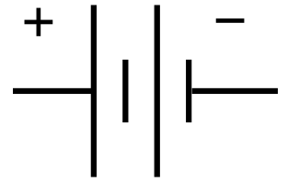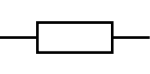

R1

4.8

3.5

5.4V

1.1A

12V



2.1

**V**

(a) Show that the resistance of resistor R1 is 4.9 Ω.

(b) Calculate the current through the power supply.

Laura now adds another resistor, R2, in parallel to resistor R1.



R1

4.8

3.5



R2

12V



2.1

Assessor’s use only

(c) Discuss how adding the additional resistor affects the power dissipated by the 3.5 Ω resistor.

Laura now uses three identical light bulbs which are labelled “24W, 12V”.

(d) Calculate the resistance of one of these bulbs at its operating voltage.

Laura now uses these three light bulbs to replace the resistors in her circuit:

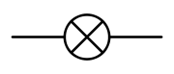

12V

Assessor’s use only

B

A

C

(e) Explain which one or ones of the three bulbs A, B, or C would use the most power, and which one or ones use the least power. Explain your answer.

##### QUESTION THREE: RADIOACTIVE DECAY AND GENERATORS

A Strontium-90 nucleus consists of protons and neutrons and is therefore positively charged. It is not magnetic. The nucleus is stationary in a magnetic field of 4.8T as shown below.

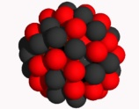

Sr-90 nucleus

Magnetic Field

(a) State the size of the force on the stationary positively charged nucleus from the magnetic field. Explain your answer.

Strontium-90 is radioactive and decays by emitting an electron from its nucleus. The energy released in this decay is transformed into kinetic energy of the electron and the remaining nucleus, which move apart in opposite directions as shown in the diagram below.



Remaining nucleus Electron

(b) Draw arrows showing the direction of the magnetic force on the electron AND the remaining nucleus.

Assessor’s use only

In this decay the electron gains 1.7 x 10-15 J of kinetic energy. The mass of an electron is 9.1 x 10-31 kg.

(c) Calculate the magnitude of the force on the electron in the magnetic field.

The diagram below shows a simple generator.

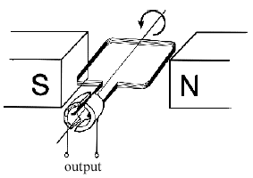

A

B

C

D

(d) On the diagram above use a **labelled** arrow to indicate the direction of the magnetic field.

Assessor’s use only

(e) On the diagram above use a **labelled** arrow to indicate the direction of the induced current in side AB.

The two sides AB and CD create a voltage, and both sides of the generator have a length of 28 cm. The magnetic field inside the generator is 1.8 T and is assumed to be uniform. The generator consists of 35 coils and has a total resistance of 8.9 Ω. The generator can produce a maximum current of 5.0 A.

(f) Calculate the maximum velocity of the generator coils.

Assessor’s use only

If you need more space for any answer, continue here. Clearly number the question.

Question Number