Name: ______________________________



**PHYSICS**

**Level 2**

91171 Demonstrate understanding of Mechanics

Credits: Six

Answer **ALL** the questions in the spaces provided.

If you need more space for any answer, use the pages provided at the back of this booklet and clearly number the question.

For all numerical answers, full working should be shown and the answer should be rounded to the correct number of significant figures and given with an SI unit.

For all ‘describe’ or ‘explain’ questions, the answer should be in complete sentences with all logic fully explained.

**YOU MUST HAND THIS BOOKLET TO THE SUPERVISOR AT THE END OF THE ASSESSMENT.**

|  |  |  |
| --- | --- | --- |
| For Assessor’s use onlyAchievement Criteria | | |
| Achievement | **Achievement** **with Merit** | **Achievement With Excellence** |
| Demonstrate understanding of  mechanics. | Demonstrate in-depth  understanding of mechanics. | Demonstrate comprehensive understanding of mechanics. |

You may find the following formulae useful.

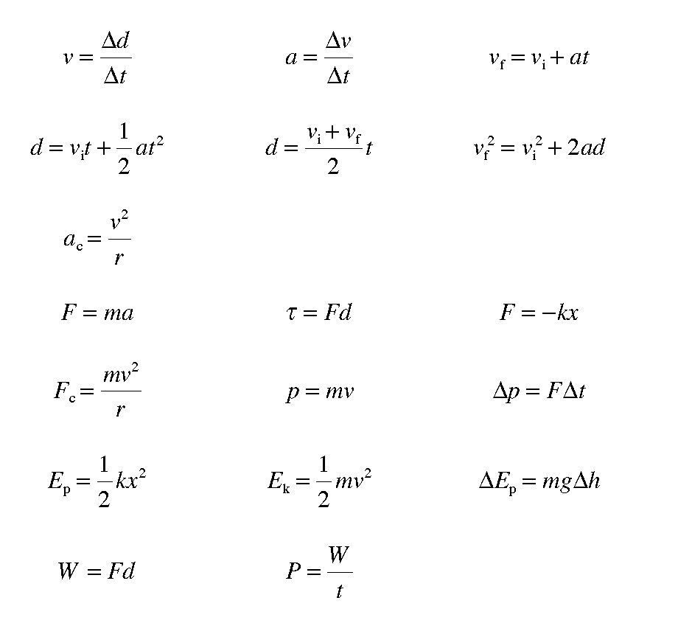

acceleration due to gravity g=9.8ms-2

circumference of circle = 2πr

|  |  |  |  |  |  |
| --- | --- | --- | --- | --- | --- |
|  | |  | |  | |
|  |  | |  | |  |

It is recommended that you take 60 minutes to complete this assessment.

Assessor’s use only

Assessor’s use only

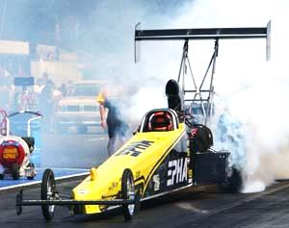

##### QUESTION ONE: AT THE DRAGS

##### Nigel has a drag car and races it over 400 m (3 s.f.). The car accelerates from rest to a speed of 88.3 m s-1 in a straight line in a time of 7.21 s.

a) Convert 88.3 m s-1 to km h-1.

b) Calculate the acceleration of the drag car.

c) Explain why decreasing the mass of the drag car would cause it to reach a higher speed over the same distance, assuming that the horizontal forces on the car remain the same.

At the end of the race, the drag car goes from 88.3 m s-1 to a stop over a distance of 250 m (3 s. f.). The drag car has a mass of 950 kg (3 s.f.).

d) Calculate the average net force on the drag car while it is stopping.

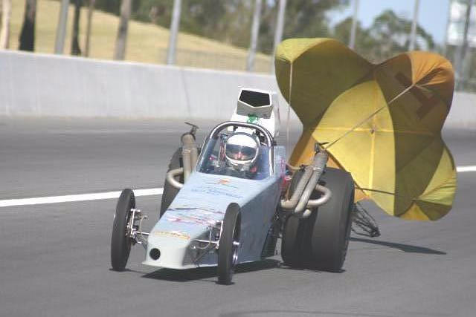e) Drag cars typically use a small parachute to help bring them to stop, as well as using traditional brakes which slow or stop the spinning of the car wheels. Explain how the parachute causes the drag car to stop, and compare this to how traditional brakes bring a drag car to a stop.

In your answer you should:

* Identify the direction of the force needed to bring a moving object to rest
* State where this force comes from in each of the parachute and traditional brakes
* Compare and contrast the parachute with traditional brakes
* Explain where the kinetic energy of the drag car goes with each braking method, and what type of energy it is transformed into.

Assessor’s use only

**QUESTION TWO: THE TOY PLANE**

A toy aeroplane is connected to a string and set to fly around a pole in a horizontal circle at a constant speed.

Assessor’s use only

a) The diagram below shows the set up viewed from above. The aeroplane is going anticlockwise from this perspective. On the diagram, draw and label the velocity and force vectors acting on the toy aeroplane.

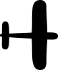

b) Explain how the toy aeroplane is accelerating, even though its speed is constant. State the definitions of acceleration and velocity in your answer.

The toy aeroplane has a mass of 0.150 kg and is in a circle with a radius of 0.65 m.

c) The centripetal force on the aeroplane is 3.2 N. Calculate the time it takes for the mass to move around its circular path once. Start by calculating the speed the aeroplane is moving with.

A defect in the string causes the string to break suddenly when the aeroplane is in the position shown below. The aeroplane continues moving.

Assessor’s use only

d) Draw the path the aeroplane would travel in as seen from above, and explain why it moves in this way.

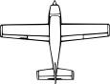



e) The toy aeroplane falls 1.4 m to the ground. Calculate the gravitational potential energy lost by the aeroplane as it falls.

**QUESTION THREE: ANCIENT WEAPONS**

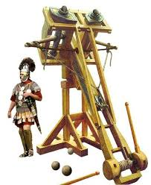

The ballista is a type of catapult that uses twisted hair or rope to store energy and then transfer it to a projectile. Claudius is hoping to hit a model of a Gaul which is standing on a hill 230 m away and 36 m above the release point of the ballista’s projectile. He fires the projectile with an initial vertical velocity of 32 m s-1, and an initial horizontal velocity of 45 m s-1.

Model of a Gaul

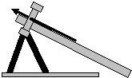

230 m

36 m

$$θ$$

Claudius’ Ballista

a) Calculate the initial speed and angle from horizontal ($θ$) of the projectile immediately after launch.

Assessor’s use only

i) Initial speed:

ii) Initial angle from horizontal:

b) During projectile motion, only one of the components of the projectile’s velocity changes. Explain which component of the velocity changes and which component stays the same, and discuss the effect this has on the motion of the projectile. Ignore the effects of air resistance.

Assessor’s use only

c) Carry out calculations to determine whether or not Claudius’ projectile will hit the target. Ignore the effects of air resistance. Start your calculation by determining the time the projectile takes to move a horizontal distance of 230 m.

Assessor’s use only

A battering ram consists of a large log suspended from a frame as shown in the illustration. The log has a mass of 1.5 × 103 kg and is lifted upwards and backwards. The log is then released and crashes against a door.

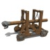

door

d) Assuming no energy is lost due to friction or air resistance, identify the energy transformations occurring as the log is released and swings towards the door.

The 1.5 × 103 kg log hits the door with a speed of 5.4 m s-1. The log then bounces back in the opposite direction with a speed of 3.2 m s-1. The time of the collision is 0.090 s.

Assessor’s use only

e) Calculate the average force (with direction) that the log applies on the wall while it is in contact. Start by calculating the initial momentum of the log.

If you need more space for any answer, continue here. Clearly number the question.

Assessor’s use only

Question Number