**Scholarship Level Score /8**

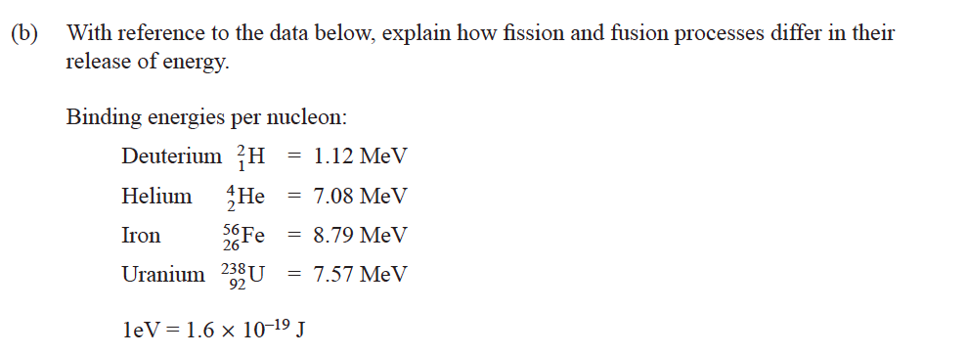

1)

2)

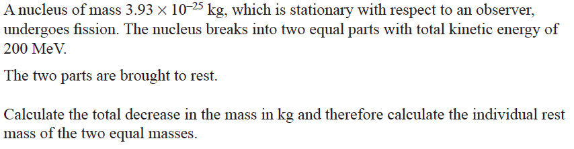

3) A nuclear fusion power station has yet to be built. One idea is to use a laser to explode lots of tiny deuterium-tritium fuel pellets in order to form helium

If one fuel pellet contains 1 x 1012 deuterium and 1 x 1012 tritium nuclei, how much energy will be released per fuel pellet?

mass deuterium ( ) = 3.3454 x 10–27 kg

mass tritium () = 5.0097 x 10–27 kg

mass helium () = 6.6483 x 10–27 kg

mass neutron () = 1.6749 x 10–27 kg

speed of light = 3.0 x 108 m s–1

4) If the diameter of a hydrogen atom is taken to be about 1 x 10–10 m, how many of the fuel pellets in part (a) would be needed to cover one side of a dollar coin? State clearly any assumptions and estimations that you make*.* [2] Hint: assume a ‘cube’ shaped pellet.

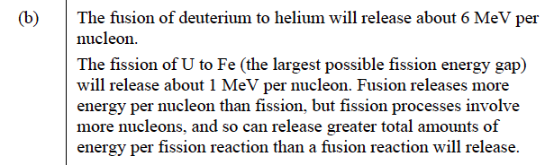

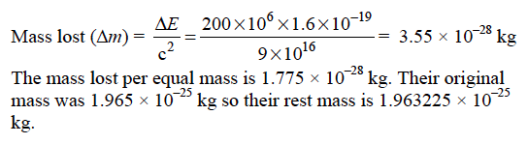

3a) Initial mass: 3.3454 × 10–27 Final mass: 6.6483 × 10–27

+5.0097 × 10–27 +1.6749 × 10–27

= 8.3551 × 10–27 = 8.3232 × 10–27

change in mass 8.3551 × 10–27 –8.3232 × 10–27  = 0.0319 × 10–27 kg

energy released E = Δmc2

= 0.0319 × 10­27 × (3 × 108)2

= 2.87 × 10–12 J

total energy released = energy one reaction x no. of reactions in a pellet

= 2.87 × 10–12 × 1 × 1012

= 2.87 J [2]

# 3b) Each pellet contains 2 x 1012 ‘hydrogen’ atoms.

# 

# Assume an atom is about 10–10 m wide.

If the pellets are cube-shaped, there will be 21/3 × 104 atoms on each side of the cube. This will mean the area of one side =  m2.

Area of a dollar coin, radius approx. 1 cm = π (10-–2)2 = π × 10–4 m2

No. of ‘Tiny’ pellets needed to cover coin  [2]