Math Diagnostic Test for NCEA L2 Physics NAME:

Graphs
1. Which of these lines below has the largest gradient (slope)? A B C D
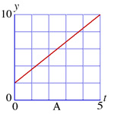 | 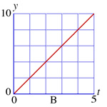 | 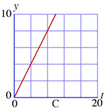 | 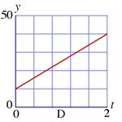
2. Which (one or more) of these graphs represent(s) a direct proportion? A B C D
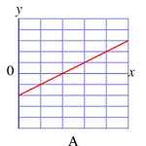 | 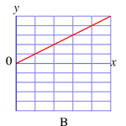 | 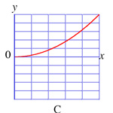 | 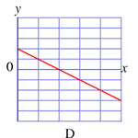
3. Which (one or more) of the graphs in question 2 represent(s) a linear function? A B C D

Trigonometry (solve for x – show full working in the space opposite each question)
4. 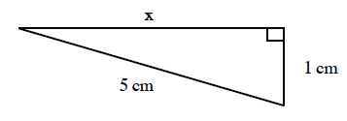
5. 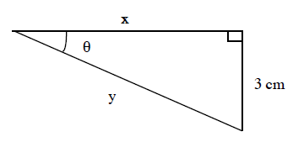
θ = 40º

Scientific Notation
In scientific work, it is convenient to express numbers as the product of a number between 1 and 10 multiplied by an appropriate power of 10. Thus 0.00050 becomes 5.0 x10⁻⁴ and 1,800,000 is written as
1.8 x10⁶. This way of writing numbers is called scientific (or powers of ten) notation.

Carry out the operations indicated and express the results in scientific notation.

6. 2 x 0.000015 = __________________________
7. (0.00002)³ = ____________________________
8. (4x10⁸) x (9x10⁹) = _______________________
9. (3x10⁷) x (6x10⁻¹²) = ______________________
Algebra (show full working in space provided for each question)

solve for x solve for x
10. 5x -7 = 11 11. 3 (x-5) = 12

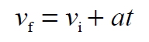
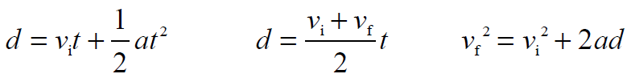
12. Solve for d:
v_{i} = 8 ms⁻¹
v_{f} = 0
d = ?
a = ?
t = 12 s

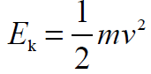
13. A ball has 28 J of Kinetic energy (E_{k}). If it has a mass of 10g, calculate the ball’s speed (v)

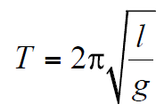

14. Given that , write an expression which contains only g on the left-hand side, ie g = ?

