Internal Assessment Resource
Achievement Standard Physics 91169: Demonstrate understanding of physics relevant to a selected context.
Resource reference: Physics 2.2
Resource title: DIY Adjustable Glasses
Credits: 3
Evidence/Judgements for Achievement | Evidence/Judgements for Achievement with Merit | Evidence/Judgements for Achievement with Excellence
The student:  - identifies and describes the characteristics of the physics related to the given context  - describes how and/or why the physics applies to this context. | The student:  - identifies and describes in-depth the characteristics of the physics related to the given context  - provides reasons how and/or why the physics applies to this context. | The student:  - comprehensively identifies and describes the characteristics of the physics related to the given context  - elaborates how and/or why the physics applies to this context  - justifies why the particular physics is well-suited to this context, and/or compares alternatives.
Student instructions
Introduction
Professor Joshua Silver, a UK physicist, has a plan for bringing clear vision to a billion poor people: $1 eyeglasses with easily adjustable, fluid-filled lenses.
According to the World Health Organisation, "there are about one billion people who would benefit from vision correction". For many of these people, glasses are unobtainable: in parts of Africa, for example, many live on less than $1 a day and there is only one optometrist per one million people.
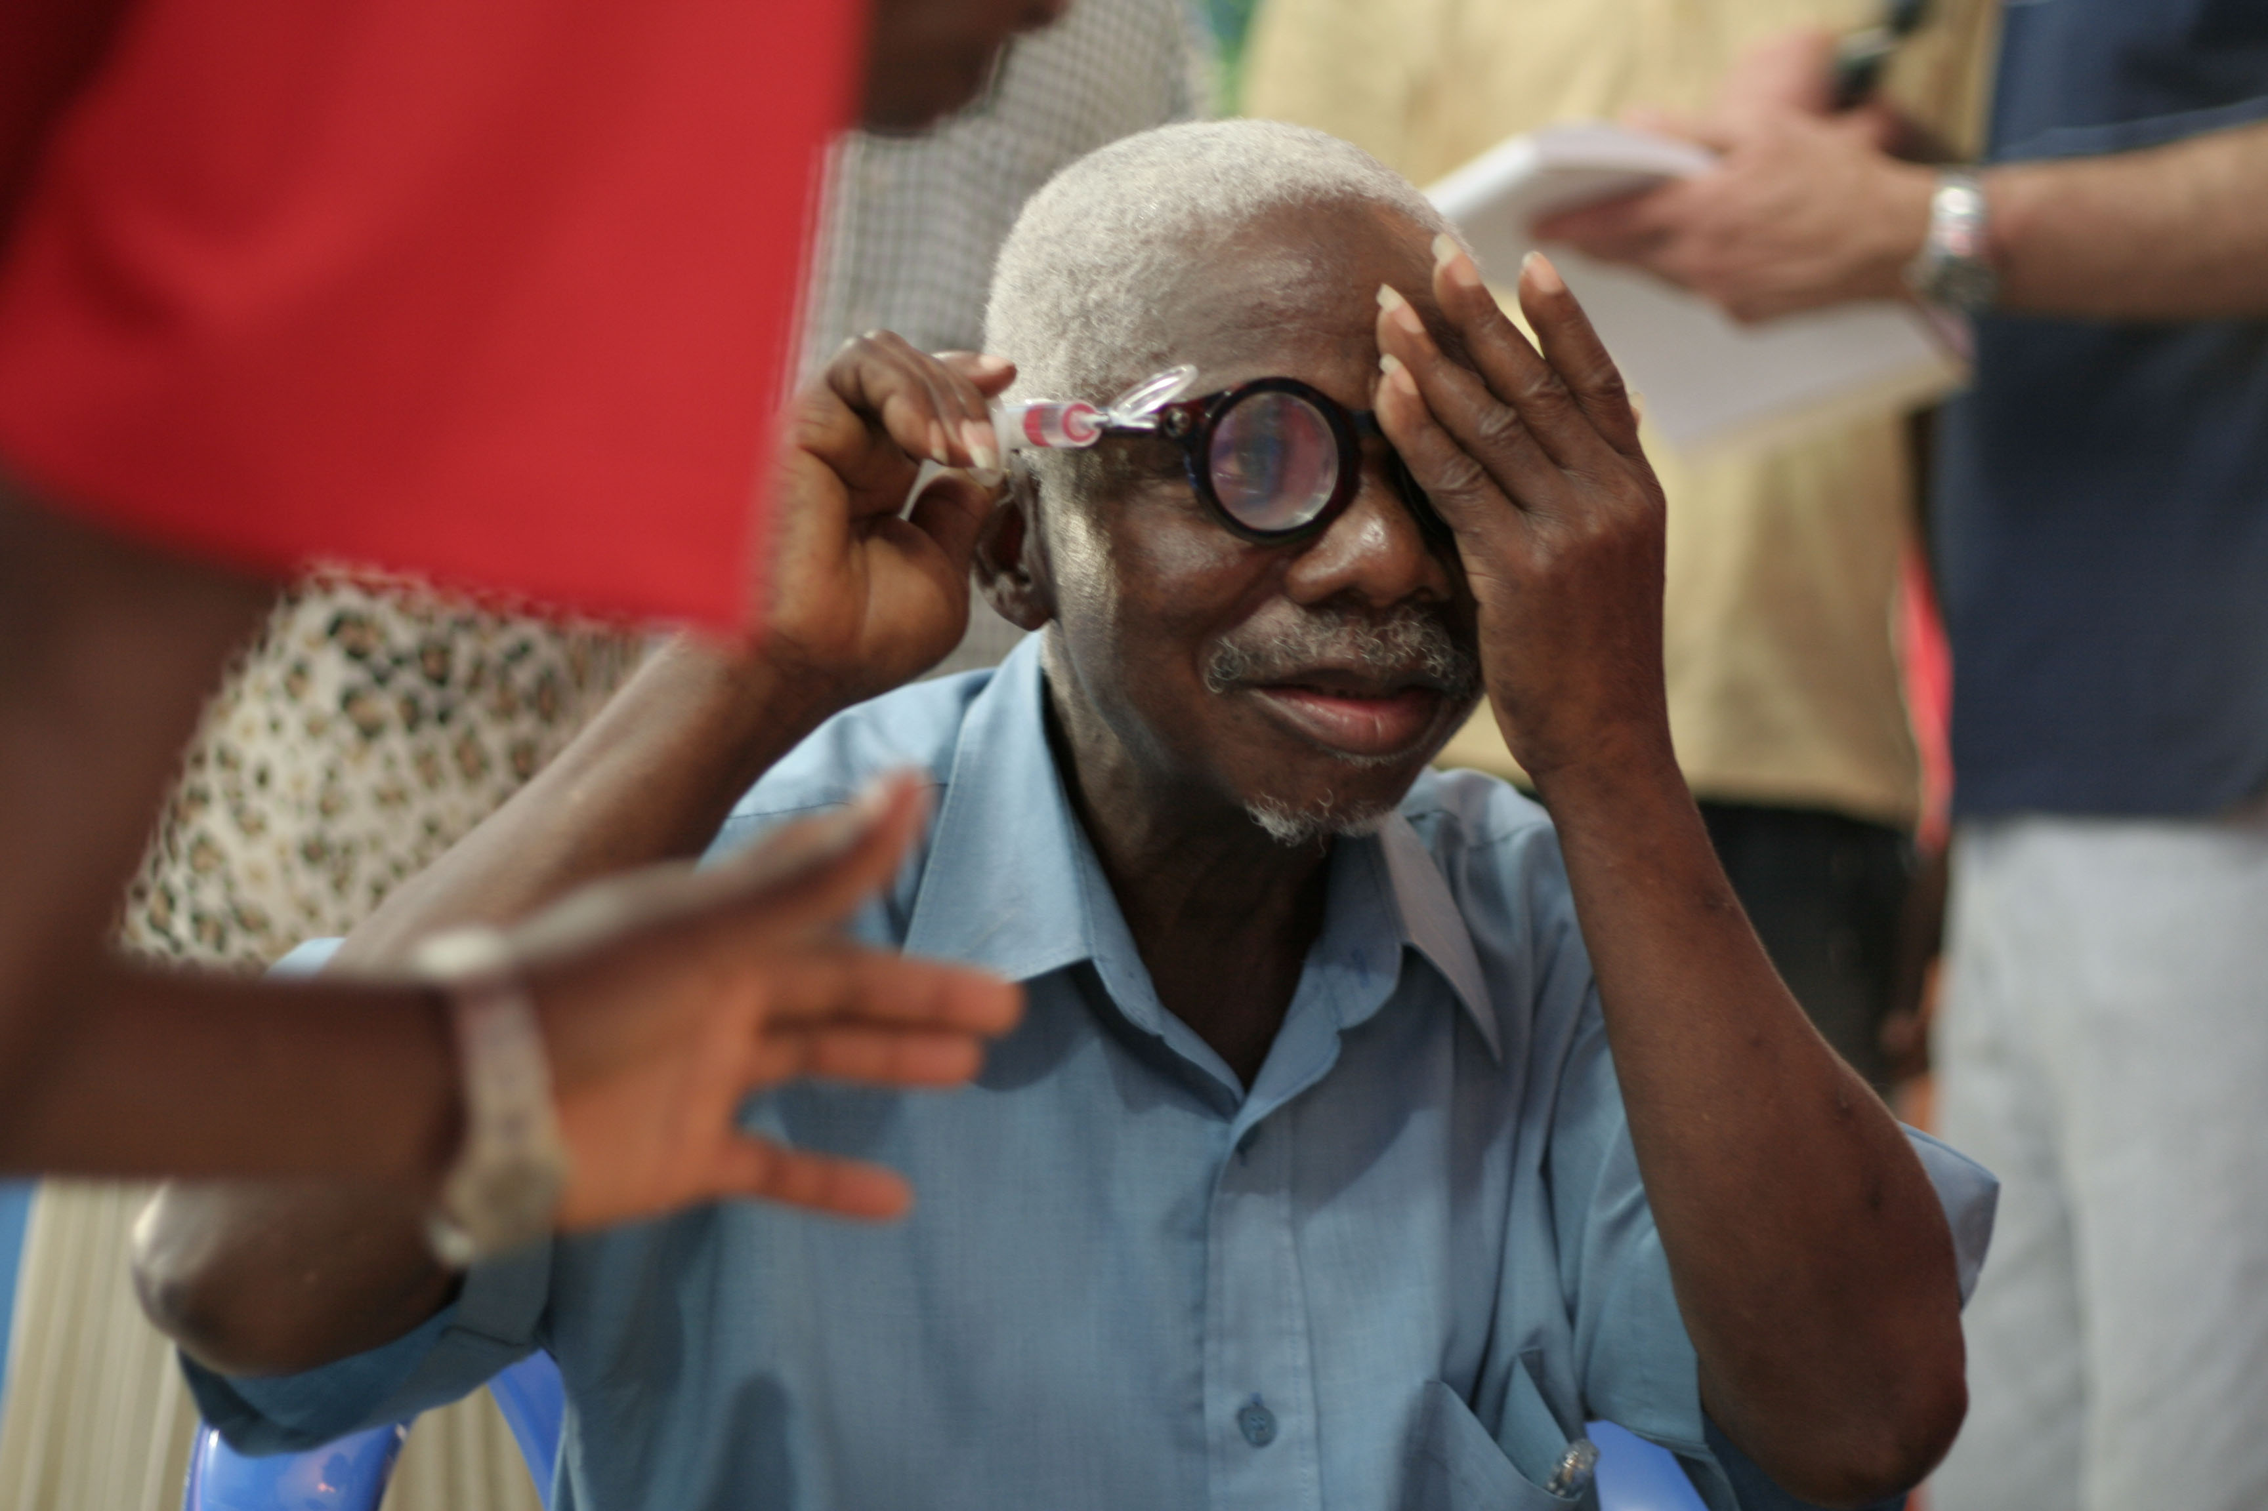
Silver invented fluid-filled lenses over 20 years ago. The fluid-filled lens is a chamber with a plastic flexible membrane on both sides. The chamber forms a clear sac that can be filled with silicone oil. The first time you put on the glasses, you use an attached syringe to adjust the amount of fluid in the sac. When your vision is clear, you seal the chamber, remove the syringe, and wear them just like normal glasses. Over 30,000 pairs have been distributed in 15 countries. Today, Silver continues to work on improving the technology and bring costs down.
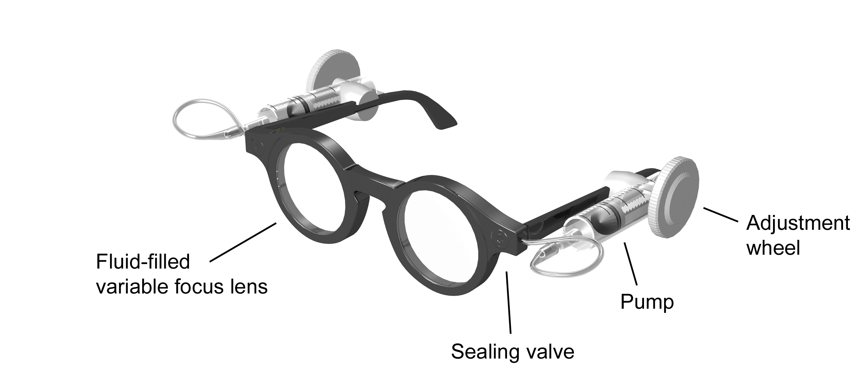

The refractive index of silicone oil is 1.406. To adjust the lens, you turn a knob that pumps fluid into or out of the chamber.
flexible membrane
fluid inside lens
fluid pumped out
fluid pumped in

In this assessment, you will research the physics of fluid-filled lenses and then prepare a report that explains the relevant physics principles.

This is an individual assessment task: you will do your own research and write your own report.

Task

Process your research information and use it as the basis for a report in which you use physics principles to explain how adjustable fluid-filled lenses work.

Your report should include the following key points:
- the physics of lenses
- how lenses are able to correct short-sightedness, long-sightedness and loss of accommodation
- why it is necessary to be able to pump the fluid in and out of the lenses
- a rationale, in terms of physics theory, for the choices that were made in the design of materials used in the glasses.

The report will be assessed on how well you describe the relevant physics and integrate it into the context of fluid-filled lenses. In your report, you should aim to elaborate, justify, evaluate, compare and contrast, or analyse the physics that underpins the context. The report will also be assessed on how well you gather and reference your information.

As a guideline, written reports should not be more than 1000 words and should include illustrations, diagrams and graphs, where appropriate (note: this page has a word count of 300 words).
The report could be modified to accommodate other formats such as:
- poster display (including supporting notes)
- video

All sources of information, images, diagrams (those not generated by the student) and data must be acknowledged and recorded in a traceable format (which means someone else could go straight to where the information came from).

Well document evidence of how your information has been gathered will need to be shown by providing:

- at least four ‘Dot – Jot’ research evaluation sheets
- Bibliography

For achievement at Merit or Excellence level, it will be expected you will be able to verbally answer questions relating to your report.

The report or agreed format and all research documentation will need to be handed in to your teacher by Friday the 24th of July.

Dot-Jot and Evaluate: an electronic copy is provided on Moodle / Weebly links
Key Idea(s)
Source (web site, newspaper, textbook etc.):
Title:
Author:
Publisher:
Year of publication:
Place of publication:
URL:
Dot-jot notes
Evaluation of Source

Assessment Schedule AS91169 (Physics 2.2): DIY Adjustable Glasses
Part A: Research Content

Evidence/Judgements for Achievement | Evidence/Judgements for Achievement with Merit | Evidence/Judgements for Achievement with Excellence
The student:  - identifies and describes the characteristics of the physics related to the given context  - describes how and/or why the physics applies to this context.  For example, they provide the following information:  - light refracts towards the normal as light enters a denser medium  - light refracts away from the normal as light leaves a denser medium  - the shape of convex lens causes light to converge  - the shape of concave lens causes light to diverge  - how an external lens in front of the eye can correct long sight and short sight.  - how the thickness / shape of the corrective lens relates to the severity of the long / short sightedness. | The student:  - identifies and describes in depth the characteristics of the physics related to the given context  - provides reasons how and/or why the physics applies to this context.  For example, they provide the following information:  - refraction is dependent on the refractive index of the lens  - different liquids have different refractive indexes, therefore different liquids have a different effect on the power of a (same shaped) fluid filled lens  - silicone oil is more suitable than water because it has a greater refractive index and so refracts light more for the same quantity of fluid  - in fluid filled convex lenses, if more liquid in pumped into the lens, the convex lens changes shape in such a way that light converges more  - in fluid filled concave lenses, if more liquid in removed from the lens, the concave lens changes shape in such a way that light diverges more  - how increased convergence or divergence of light improves specific vision problems. | The student:  - comprehensively identifies and describes the characteristics of the physics related to the given context  - elaborates how and/or why the physics applies to this context  - justifies why the particular physics is well-suited to this context, and/or compares alternatives.  For example, they provide the following information:  - refraction and therefore lens power is a function of the refractive index of the lens material  - silicone oil has a greater refractive index than water, but smaller refractive index than glass or plastic – lenses made of silicone oil must be thicker than glasses made of glass or plastic and are therefore “clunky” compared to them  - a detailed explanation of how concave lenses reduce short-sightedness including details of what short-sightedness is, what a short-sightedness person would see without the aid of glasses, and how the glasses help a short-sightedness person  - a detailed explanation of how convex lenses reduce long-sightedness and loss of accommodation including details of what long-sightedness/loss of accommodation is, what a long-sightedness/loss of accommodation person would see without the aid of glasses, and how the glasses help a long-sightedness/loss of accommodation person.

Assessment Schedule AS91169 (Physics 2.2): DIY Adjustable Glasses
Part B: Information Gathering

Evidence/Judgements  for Achievement | Evidence/Judgements  for Achievement with Merit | Evidence/Judgements  for Achievement with Excellence
Has 2 complete ‘Dot – Jot’ research evaluation sheets | Has 3 complete ‘Dot – Jot’ research evaluation sheets | Has 4 or more complete ‘Dot – Jot’ research evaluation sheets
Sources:  - the few sources used follow no reasoned standard of selection  - has not evaluate sources | Sources:  - uses several sources of more than one kind  - has evaluates some sources for relevance | Sources:  - uses a range of sources with varied  - formats  - points of view  - evaluates all sources for relevance
Dot – Jot note taking:  - information in notes is mostly of general, rather than direct and clear, relevance to ‘key’ idea being researched  - limited evidence shown in report that information presented is sourced from Dot- Jot note taking | Dot – Jot note taking:  - information in notes is mostly directly and clearly relevant to ‘key’ idea being researched  - some evidence shown in report that information presented is sourced from Dot- Jot note taking | Dot – Jot note taking:  - information in notes is consistently, directly, and clearly relevant to ‘key’ idea being researched  - clear evidence shown in report that information presented is sourced from Dot- Jot note taking
Bibliography  - includes most sources cited in notes  - is mostly in correct alphabetical order | Bibliography  - includes all sources cited in notes  - is in correct alphabetical order
Traceable Format  Most sources of information, images, diagrams, and data are referenced in a format that enables them to be easily traced. | Traceable Format  All sources of information, images, diagrams, and data are referenced in a format that enables them to be easily traced.

- Sufficiency must be met in both A & B parts.
- For achievement at Merit or Excellence level, you may be expected to verbally answer questions relating to your report.
- Final grades will be decided using professional judgement based on a holistic examination of the evidence provided against the criteria in the Achievement Standard.

Images supplied with permission by the Centre for Vision in the Developing World (http://www.vdw.ox.ac.uk/). Information about fluid-filled lenses abridged and amended from http://blogs.discovermagazine.com/discoblog/2009/01/05/cheap-liquid-glasses-bring-clear-vision-to-the-poor/.

