BEANZ Practice Examination  Level 3 Biology  2012 |  | Student Name / Code:  ____________________________________

King’s High School

Biology NCEA Level 3

Achievement Standard 90716

B3.4 Describe animal behaviour and plant
responses in relation to environmental factors

Credits: 4

Instructions:
- You should answer ALL the questions in this booklet
- Check that this booklet has pages 2 - 11 in the correct order and that none of these pages is blank
- YOU MUST HAND THIS BOOKLET TO THE SUPERVISOR AT THE END OF THIS EXAMINATION
- You are advised to spend 45 - 55 minutes answering the questions in this booklet

Achievement Criteria:
Achievement |  | Achievement with Merit |  | Achievement with Excellence
Describe animal behaviour and plant responses in relation to environmental factors |  | - Describe animal behaviour and plant responses in relation to environmental factors  - Explain animal behaviour or plant responses in relation to environmental factors |  | - Describe animal behaviour and plant responses in relation to environmental factors  Discuss animal behaviour or plant responses in relation to environmental factors

Overall Level of Performance:

Question 1 Plant gravitropic responses

The diagram below shows the effect of the auxin IAA (indol acetic acid) on cells in the growing tips of roots and shoots of dicotyledonous angiosperms
Concentration of plant hormone

Growth is inhibited
Growth is stimulated
Shoot growth
Root growth

- Describe and explain the action of auxin (IAA) on plant cells when a plant responds to the stimulus of gravity.
Use a labelled diagram to show changes in the cells associated with the growing tips of the shoot of the plant.

________________________________________________________________________________

________________________________________________________________________________

________________________________________________________________________________

________________________________________________________________________________

________________________________________________________________________________

________________________________________________________________________________
Space for a diagram:

As plants grow they continue to respond to gravity.
Cell growth will ensure that the plant has the best access to resources from the environment.

- Discuss how both negative and positive gravitropism will orientate the plant as it grows.
In your answer:
- explain how plant shoot growth is upward yet in the root, growth is downward
- use information from the graph to explain how one plant hormone can cause different effects in different parts of the plant. (You may add notes to the diagram on the previous page and refer to them in your explanation).
- discuss the relationship between the auxin effect in the root and that in the shoot.
(You may refer to the role of other plant growth factors to explain gravitropic responses)

_________________________________________________________________________________

_________________________________________________________________________________

_________________________________________________________________________________

_________________________________________________________________________________

_________________________________________________________________________________

_________________________________________________________________________________

_________________________________________________________________________________

_________________________________________________________________________________

_________________________________________________________________________________

_________________________________________________________________________________

_________________________________________________________________________________

_________________________________________________________________________________

_________________________________________________________________________________

_________________________________________________________________________________

_________________________________________________________________________________

_________________________________________________________________________________

_________________________________________________________________________________

_________________________________________________________________________________

_________________________________________________________________________________

_________________________________________________________________________________

_________________________________________________________________________________

_________________________________________________________________________________

_________________________________________________________________________________

_________________________________________________________________________________
Question 2 Crayfish on the move  Crayfish in New Zealand belong to one of two species of rock lobster; red rock lobsters and the larger packhorse lobsters. Rock lobsters can migrate in large numbers up to 1000 km, often over the open sea floor and often during the day. They have been known to head south and walk the entire length of the New Zealand west coast, walking in the opposite direction to prevailing water currents. | 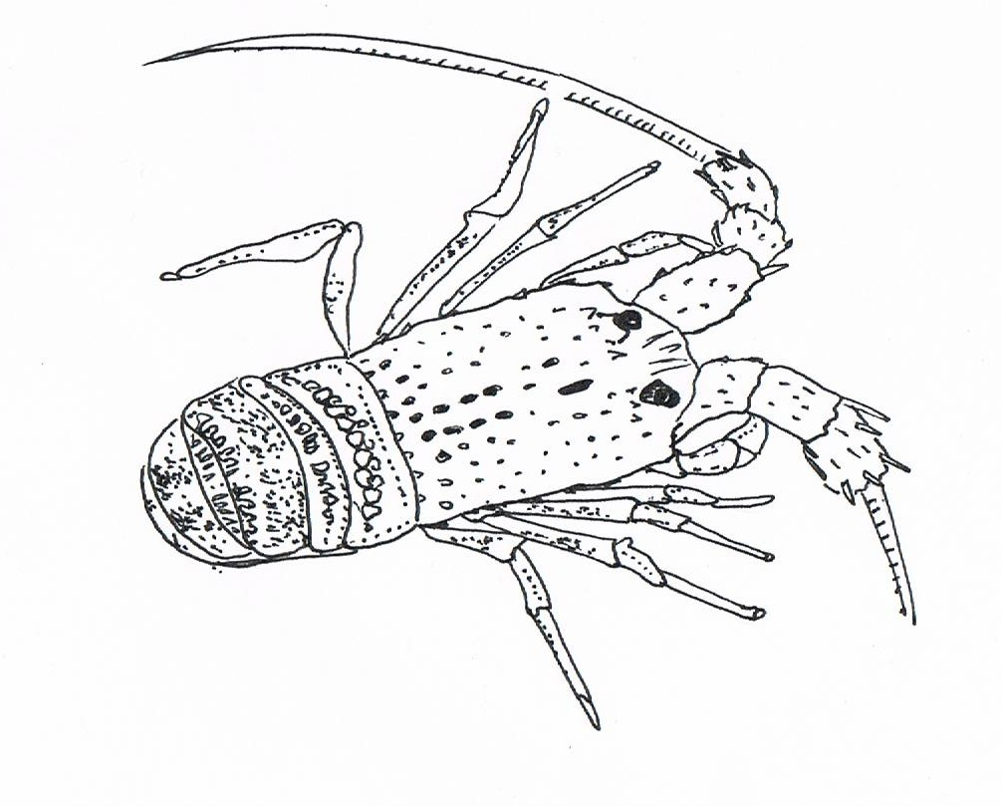

- Use correct biological terms to define migration.

_________________________________________________________________________________

_________________________________________________________________________________

_________________________________________________________________________________

- Describe which environmental factors are known to initiate migration for many species of animal and explain why these cues are reliable.

_________________________________________________________________________________

_________________________________________________________________________________

_________________________________________________________________________________

_________________________________________________________________________________

_________________________________________________________________________________

_________________________________________________________________________________

_________________________________________________________________________________

_________________________________________________________________________________

_________________________________________________________________________________

_________________________________________________________________________________

_________________________________________________________________________________

_________________________________________________________________________________

_________________________________________________________________________________

_________________________________________________________________________________
- With reference to the New Zealand species, discuss the benefits and risks of migration to crayfish as individuals and as a species.
Your answer should:
  - list two resources that are needed by individual crayfish which may necessitate migration
  - explain how they may find their way
  - explain the disadvantage of moving together as a group at a predetermined time of the year
  - compare the likely outcome for a ‘non migrating’ crayfish individual to the success of a crayfish that moves with the group and discuss long term survival benefits of the species of migratory behaviour

_________________________________________________________________________________

_________________________________________________________________________________

_________________________________________________________________________________

_________________________________________________________________________________

_________________________________________________________________________________

_________________________________________________________________________________

_________________________________________________________________________________

_________________________________________________________________________________

_________________________________________________________________________________

_________________________________________________________________________________

_________________________________________________________________________________

_________________________________________________________________________________

_________________________________________________________________________________

_________________________________________________________________________________

_________________________________________________________________________________

_________________________________________________________________________________

_________________________________________________________________________________

_________________________________________________________________________________

_________________________________________________________________________________

_________________________________________________________________________________

_________________________________________________________________________________

_________________________________________________________________________________

_________________________________________________________________________________

_________________________________________________________________________________

_________________________________________________________________________________
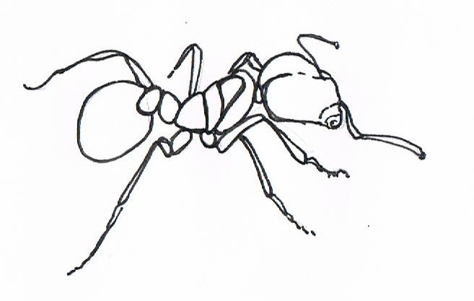  Question 3 | Busy Bees and Ant Armies  Social insects display very strong intraspecific relationships (between individuals). In some instances, this behaviour allows the colony to act almost as one organism; such is the strength of their division of labour. These relationships may be further strengthened by genetic controls and social insects of the same colony will be close relatives or even genetically identical. Whatever the case, organisms need to communicate effectively to respond to the environment in an appropriate way.

  - Using a named species of social insect describe how large colonies are formed.

_________________________________________________________________________________

_________________________________________________________________________________

_________________________________________________________________________________

_________________________________________________________________________________

  - Describe how control is maintained within the colony and using one named example, explain the importance of successful communication between individuals.

_________________________________________________________________________________

_________________________________________________________________________________

_________________________________________________________________________________

_________________________________________________________________________________

_________________________________________________________________________________

_________________________________________________________________________________

_________________________________________________________________________________

_________________________________________________________________________________

_________________________________________________________________________________

_________________________________________________________________________________

_________________________________________________________________________________

_________________________________________________________________________________
  - Consider the social insect regime and discuss the benefits and risks of social behaviour to the individual animal and to the colony as a whole.
In your answer you should:
- describe the resources that animals are able to access more effectively as a large group
- explain the division of labour opportunities for a large group
- discuss the range of solutions which overcome the difficulties of communication in a large group
- discuss the costs and benefits of the seasonal activity of social insects and long term survival of the group.

_________________________________________________________________________________

_________________________________________________________________________________

_________________________________________________________________________________

_________________________________________________________________________________

_________________________________________________________________________________

_________________________________________________________________________________

_________________________________________________________________________________

_________________________________________________________________________________

_________________________________________________________________________________

_________________________________________________________________________________

_________________________________________________________________________________

_________________________________________________________________________________

_________________________________________________________________________________

_________________________________________________________________________________

_________________________________________________________________________________

_________________________________________________________________________________

_________________________________________________________________________________

_________________________________________________________________________________

_________________________________________________________________________________

_________________________________________________________________________________

_________________________________________________________________________________

_________________________________________________________________________________

_________________________________________________________________________________

_________________________________________________________________________________

_________________________________________________________________________________

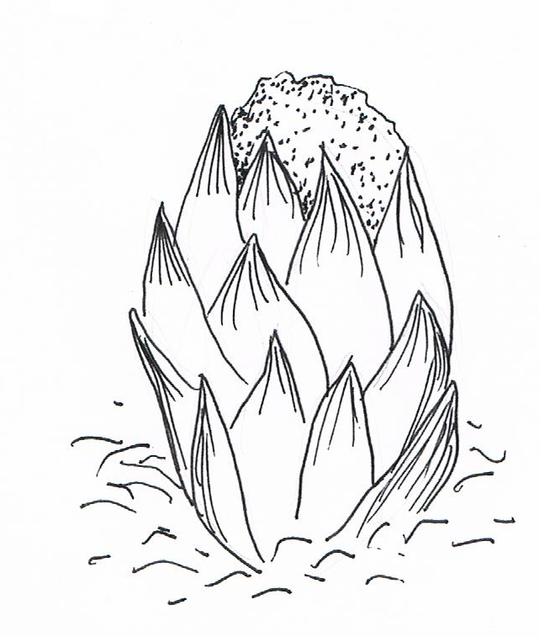
Question 4 Bats and Roses

The endangered native wood rose (Dactylanthus taylorii) is a parasitic plant that grows on the forest floor. Its distribution is now confined to protected exclosures in NW Nelson. The cause of its diminished range and numbers is probably due to introduced rat populations feeding on the plant structure as well as robbing the nutrient rich nectar. Twenty four hour video monitoring of the plant has revealed that a native mammalian species, the Long Tailed bat, is a frequent visitor to the plant by night. The only bat in the world adapted to be able to crawl along the ground, it seems this NZ native bat systematically visits all plants within its range, attracted by a strong scent, specific to bat sensitivity. As it forages the bat transfers pollen from plant to plant while taking advantage of the “bat-sized” portions of nectar.
Dactylanthus taylorii flower
Information and drawing adapted from information on Lincoln University website

- Describe, using correct biology terminology, the relationship between the wood rose and the native bat.

_________________________________________________________________________________

_________________________________________________________________________________

_________________________________________________________________________________

_________________________________________________________________________________

- Discuss the risks to long term survival and the benefits of this strong interspecific relationship to both the wood rose and the bat.
In your answer you should
- describe adaptations of the bat and wood rose that are useful in sustaining this relationship
- describe the relationship between the introduced rat and the wood rose and provide possible explanations why the rat is not an effective pollinator of the wood rose
- explain the benefits to both the bat and wood rose species of the pollinating relationship
- discuss the long term risks to both species caused by the specific nature of this relationship.

_________________________________________________________________________________

_________________________________________________________________________________

_________________________________________________________________________________

_________________________________________________________________________________

_________________________________________________________________________________

_________________________________________________________________________________

_________________________________________________________________________________

_________________________________________________________________________________

_________________________________________________________________________________

_________________________________________________________________________________

_________________________________________________________________________________

_________________________________________________________________________________

_________________________________________________________________________________

_________________________________________________________________________________

_________________________________________________________________________________

_________________________________________________________________________________

_________________________________________________________________________________

_________________________________________________________________________________

_________________________________________________________________________________

_________________________________________________________________________________

_________________________________________________________________________________

_________________________________________________________________________________

_________________________________________________________________________________

_________________________________________________________________________________

_________________________________________________________________________________

_________________________________________________________________________________

_________________________________________________________________________________

_________________________________________________________________________________

_________________________________________________________________________________

_________________________________________________________________________________

_________________________________________________________________________________

_________________________________________________________________________________

_________________________________________________________________________________

_________________________________________________________________________________

_________________________________________________________________________________

Question 5 The curious case of the Frost Fish – an easy catch

In winter, early morning visitors to southern ocean beaches will occasionally beat the scavenging seagulls to a feast of fresh fish. On very frosty mornings after a full moon, fish known to locals as ‘Frost Fish’ will occasionally be found alive and wriggling, but apparently ‘beached’, in the shallow waters of gently sloping, sandy beaches. These are very deep water fish that are never caught in the nets of coastal fishermen. The fish appear to be completely healthy (and good eating!). A study of the carcass reveals that the fish has enlarged reproductive organs and is clearly in the process of midwinter mating which is carried out by external fertilisation. After fertilisation the developing zygotes of the Frost Fish are distributed by ocean currents.

  - Describe an environmental cue that could trigger mating behaviour in marine organisms.

_________________________________________________________________________________

_________________________________________________________________________________

_________________________________________________________________________________

_________________________________________________________________________________

  - Discuss the advantages and disadvantages of synchronising mating and spawning to an environmental cue.
In your answer you should:
- describe the likely conditions of the deep water environment of the Frost Fish
- explain why an environmental cue is advantageous to initiate mating
- explain the beaching behaviour following a full moon
- discuss the biological processes that will allow a marine fish such as this to be prepared for mating at the same time each year.

_________________________________________________________________________________

_________________________________________________________________________________

_________________________________________________________________________________

_________________________________________________________________________________

_________________________________________________________________________________

_________________________________________________________________________________

_________________________________________________________________________________

_________________________________________________________________________________

_________________________________________________________________________________

_________________________________________________________________________________

_________________________________________________________________________________

_________________________________________________________________________________

_________________________________________________________________________________

_________________________________________________________________________________

_________________________________________________________________________________

_________________________________________________________________________________

_________________________________________________________________________________

_________________________________________________________________________________

_________________________________________________________________________________

_________________________________________________________________________________

_________________________________________________________________________________

_________________________________________________________________________________

_________________________________________________________________________________

_________________________________________________________________________________

_________________________________________________________________________________

_________________________________________________________________________________

_________________________________________________________________________________

_________________________________________________________________________________

_________________________________________________________________________________

_________________________________________________________________________________

_________________________________________________________________________________

_________________________________________________________________________________

_________________________________________________________________________________

_________________________________________________________________________________

_________________________________________________________________________________

_________________________________________________________________________________

_________________________________________________________________________________

_________________________________________________________________________________

_________________________________________________________________________________

_________________________________________________________________________________

