**Scholarship Level ‘Simple Harmonic Motion’ Score / 10**

(1) (i) A weighted glass tube floats vertically in water.

It is pushed down and released. Does it oscillate in SHM? [1]

(ii) The tube is 150 g. When it is pushed down 10 mm it has a restoring force of 0.010 N.

Calculate its period. [1]

1. A particular tide has a 4.0 m difference between high and low. A reef at the entrance to a harbour is 1.5 m below high tide. Harry’s boat has a draught of 0.60 m. How many hours per tide is it safe to enter the harbour? (reference circle problem) [1]



acceleration

(3) As you travel outwards from the centre of the earth,

the acceleration due to gravity increases then decreases.

1. Sketch this on a graph shown. [1}
2. If a tunnel was bored through the earth’s centre, you could travel to Madrid simply by stepping into the hole. How long would it take? [1]

distance

Let g= 9.81 ms-2 at surface., RE = 6300 km

*What sort of motion is it? (assume SHM…)*

*Write an equation for the acceleration as a function of distance to the centre.*

*Calculate the constant.(ie solve for ω from a =-ω*2y)



A

B

1.0 m

(4) (i) A mouse is in a parabolic bowl. It wants to get the ball out of the bowl but is unable to apply

sufficient force. Explain how she might do it. [1]

(ii) Explain why the ball oscillates in SHM, but the ball in the bowl below with **straight sides does not**. [2]

(iii) The ball’s mass is 120 g. If the ball takes 3.0 s to roll from A to B, calculate the total energy at any time. [1]

(iv) Sketch a graph of acceleration/time for one oscillation, starting at A. Include numbers. [1]

**Scholarship Level Solutions**

1) i) *Gravity force downwards is constant. The buoyancy force is proportional to the distance the tube is pushed down. So there is an upward force proportional to the displacement. As is rises above equilibrium, the buoyancy force decreases in proportional to the distance above equilibrium., so there is a downward force proportional to displacement. This is the condition for equilibrium: (F α – x)*

(ii) 

2) *From the information, the boat can enter when the water is between high tide and 0.90 m below high tide.(i.e. 1.1 m above mid tide)*



*Calculate θ*

*Multiply by 2*

*Convert this angle to time*

θ

1.1

2.0

3) i) 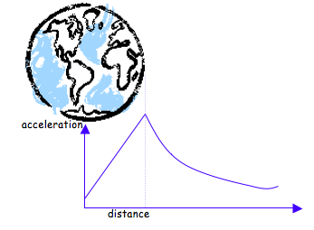ii)



4) i) *Give it a push a regular intervals at the natural period. This will cause the amplitude to slowly increase – ie concept of resonance.*

*ii) If the bowl is parabolic its* ***gradient*** *is proportional to the horizontal distance from equilibrium. (The differential of y=x2 is y’= 2x. Therefore the restoring force caused by the slope is proportional to the horizontal distance from equilibrium. i.e. it is SHM*

*If the sides are straight, the restoring force is constant.*

*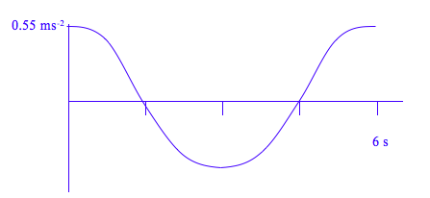iii)* 

iv) *amax = -ω2A*