Internal Assessment Resource
Achievement Standard Physics 91522 v1: Demonstrate understanding of the application of physics to a selected context
Resource reference: Physics 3.2
Resource title: In a Spin
Credits: 3
Achievement | Achievement with Merit | Achievement with Excellence
Demonstrate understanding of the application of physics to a selected context. | Demonstrate in-depth understanding of the application of physics to a selected context. | Demonstrate comprehensive understanding of the application of physics to a selected context.
Student Instructions
Introduction
Making something rotate is often a fundamental aspect of a sporting action.

 | 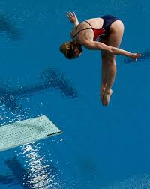 | 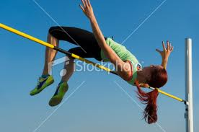

Task
Working independently, gather information on the following three sporting actions that involve rotation.
- Making the ball rotate as well as translate in the sport of tennis (or cricket).
- Making the body spin in the sport of high diving (or trampolining).
- Making the body rotate over the bar when executing a high jump.
Use the information you have gathered and your knowledge of the physics of rotational motion to produce a report that describes and explains the physics of each sporting action.

Report
The format of the report will be a written report. It must be written in your own words and needs to include the following information.

For a cricket or tennis ball:
- What factors affect the amount of spin.
- How spin affects the flight of the ball after it has been hit.
- How the spin affects the bounce of the ball.
For a high diver or trampolinist:
- How the spin is created.
- How the number of spins can be maximised.
For a person executing a high jump:
- How the rotation is created.
- The advantage of using this method rather than just jumping over the bar.

Your report will be assessed on how well you explain, integrate or link the relevant physics to the sporting action. The Physics understanding needs to relate to the y12 and Y13 Mechanics learning objectives.

The report should be approximately four pages in length or 1500 words (note: this page has a word count of 400 words). The report should include illustrations, diagrams and graphs where appropriate.
The report could be modified to require other formats such as:
- poster presentation (including annotations or supporting notes)
- power point presentation with voice over display

All sources of information, images, diagrams (those not generated by the student) must be acknowledged and recorded in a traceable format (which means someone else could go straight to where the information came from).

Well document evidence of how your information has been gathered will need to be shown by providing at least six ‘Dot – Jot’ research evaluation sheets.

For achievement at Merit or Excellence level, you maybe expected to verbally answer questions relating to your report.

You will be given 5 weeks of class time to carry out your research, produce your research materials (Dot – Jot sheets) and to write your report.
It is recommended that you trial using Google Doc and ‘cloud computing’ to store your work and also be able to connect with your teachers who can give feedback on your work.

Time line to be followed:
Term 3, Weeks 6,7,8 & 9: carry out your research in class via iPads, Library computers, B8 computers or BYOD.
Note: at least one of these week will be spent reviewing the Term 3 Practice exam.
Monday of week 10, draft report copy to supervisor.
Final report copy to supervisor last day of Term 3.

