TASK A: complete a mind map of 1) 2) & 3)

Use pages 59 to 85 from your course book by reviewing the relevant **theory** section (grey box)

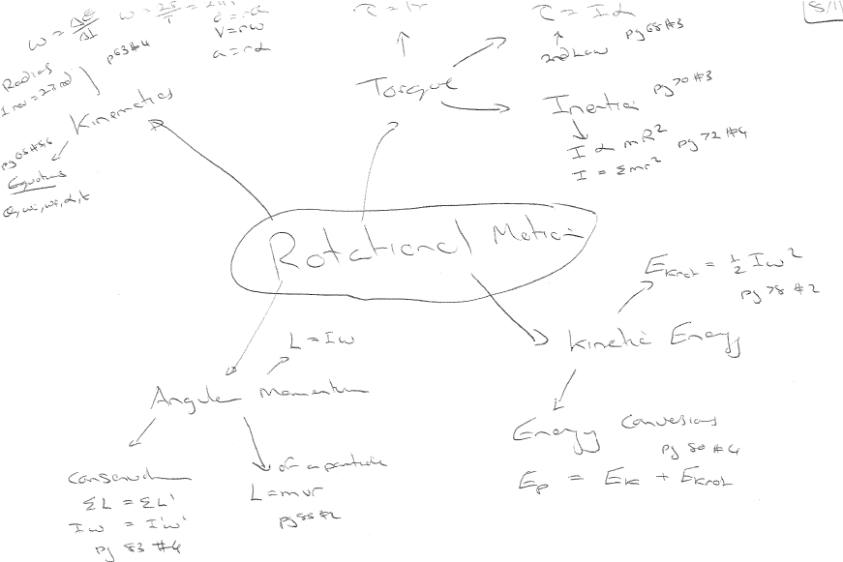

TASK B ~ EXPLAIN AND UNDERSTANDING PHYSICS DIAGRAMS MAKES FOR EXCELLENT REVISION!

**Be familiar with the COMMON DIAGRAMS and GRAPHS in this unit:**

1. Graphs of angular displacement vs time and angular velocity vs time

* Gradient of θ vs t graph = angular velocity (ω)
* Gradient of ω vs t graph = angular acceleration (α) and AREA of this graph = angular displacement (θ)
* 1st graph shows constant angular velocity, then stationary (flat line) then negative angular velocity (spinning opposite direction) at a faster speed than at the start. Graph finishes with wheel exactly as it started (zero angular displacement).
* 2nd graph shows stationary wheel, then spins backwards at constant angular velocity, then stops, then spins backwards again (at the same velocity) then finally stops.
* 3rd graph shows constant angular acceleration from rest to a constant angular velocity (flat line) then an angular deceleration to a stop. Area of this parallelogram is the angular displacement.
* 4th graph shows constant angular velocity, then a deceleration to a stop, then an angular acceleration in the OPOSITE direction to spin up the other way to a constant negative angular velocity.

2. Experiment diagram from angular acceleration of turntable (horizontal wheel) from linear motion of mass.

* ?1 = tension force which equals ?4
* ?2 = weight force (mg) which is theoretically slightly larger than tension so that mass accelerates downwards but the acceleration will be very small (usually less than 1m/s/s)
* ?3 = net force on hanging mass (weight minus tension). Again, usually very small and most books ignore this and use tension = weight.
* The turntable will acceleration because of the torque and can be used with the tension to find the rotational inertia of the table.

3. Ball starting from rest uniformly accelerating (linearly and rotationally) down the ramp.

* Conservation of energy situation.
* Ball starts with gravitational potential energy (mgh). At bottom of ramp ball has BOTH linear kinetic and rotational kinetic energies.
* Equation used is:  .
* With values given we can find rotational inertia (eventually):
* θ = s/r = 9.6/0.07 = 137.14… rad
* h = 9.6 x tan 22 = 3.878…m
* giveswith initial speed of zero: ωf = 19.591… rad/s
* vf = r ωf = 1.37… m/s
*  gives 0.00347… kg m2

4. Solid and hollow cylinders rolled down same ramp from rest.

* If both have the same mass, then the hollow object will reach the bottom LAST because the hollow object has MORE rotational inertia.
* Mass distribution for the hollow object is farther from the centre of rotation, thus more rotational inertia.
* Solid objects have mass distribution closer to the centre thus solid object have LESS rotational inertia.
* Objects with less rotational inertia will have more of their gravitational potential energy converted into LINEAR kinetic energy and less into rotational kinetic energy, thus they reach the bottom faster.

5. Diagram for “helicopter” example where 2 masses rotate in opposite directions but angular momentum is conserved.

* ?1 = the blades of the helicopter with smaller mass and smaller rotational inertia.
* ?2 = the angular velocity of the blades
* ?3 = the body of the helicopter with much more mass and much more rotational inertia
* ?4 = the angular velocity of the body of the helicopter (assuming the rear rotors aren’t working).
* The angular momentum of the blades (L=I1ω1) must equal the angular momentum of the body (L=I2ω2) IF we ASSUME there are NO EXTERNAL TORQUES from friction or rear rotors.

6. Conservation of angular momentum example with turntable and movable masses that rotates at angular velocity (?1).

* As the masses move inwards like an ice skater pulling their arms inwards (the mass distribution changes) so that there is LESS rotational inertia.
* Since L is conserved (because of no external torques) then the angular velocity INCREASES.
* Lbefore = Lafter can be used with L=Iω
* The extra rotational kinetic energy (with masses closer to the center) comes form the work done pulling the masses closer to the centre (W=Fd).

7. Conservation of angular momentum with a bullet (?1) moving at linear velocity (?2) being “caught” by a pocket on a vertically mounted turntable.

* The pocket has a smaller radius (?3) than the wheel’s radius (?4).
* The torque supplied by the bullet lodging into the pocket give the wheel rotational momentum with L=mvr using the pocket’s radius and the bullet’s mass and velocity.
* Once spinning, if the pocket is moved to a larger radius (?4) then the mass distribution is altered (like an ice skater letting their arms go out) and the wheel SLOWS down.
* Lbefore = Lafter can be used with L=Iω

|  |  |  |  |  |
| --- | --- | --- | --- | --- |
| **Question** | **Evidence** | **Achievement** | **Merit** | **Excellence** |
| Q1  (a) | v = u +at    = 2.22 ms-2 | 2 See evidence |  |  |
| (b) | a = rα    = 6.34 rads-2 | 2 Correct formula and shows or implies that  r = 0.350m | 2 See evidence |  |
| (c) | τ = Fr  = 333 x 0.350  = 117Nm | 2 Gets the unbalanced force correct (F=333N) | 2 See evidence |  |
| (e) |  | 2 See evidence |  |  |
| (f) | The (anticlockwise) torque due to the motor turning the wheel (force between wheel and the ground times radius of the back wheel) is greater than the clockwise torque of the force of gravity of the bike and the rider Neil about the centre of mass. | 1 Recognises that torque due to wheel or motor is greater than torque due to bike and rider | 1 Recognises that the torque is calculated (or is measured) from the COM of the bike and rider | 1 Achieved plus meritwith a clear and concise explanation |

**TASK C: Practice NCEA application based questions**

|  |  |  |  |  |  |
| --- | --- | --- | --- | --- | --- |
| Q2a |  | |  | 2 See evidence |  |
| 2b |  | | 2 See evidence |  |  |
| 2c |  | | 2 See evidence |  |  |
| 2d |  | W  2kg  R  T  T=tension  W=Force of gravity  R=Resultant | 2 Draws a correct free body diagram | 2 Draws a correct free body diagram with resultant correctly and clearly shown | 2 Merit plus correct working top show that the resultant is 12 N. Remember this **is a show question therefore working must be shown** |
| 2e | Torque = Fd=12x0.2=2.4Nm | | 2 See evidence |  | 1 |
| 2f | So Rotational Inertia =  I=  I= 0.12kgm2 | | 2 Gives correct unit kgm2 | 2 See evidence |  |
| 2g | Rotational inertia will be greater for the hollow cylinder. This is because I=kmr2 or I α r2. Therefore the hollow cylinder will have all its mass at a greater distance from the turning point than the solid cylinder (if the masses are the same) in which the mass is spread evenly form the centre to the outside and will have a smaller “r”. For the hollow cylinder its mass is all at its outer rim so its “r” will be greater and so will have the greater rotational inertia I. | | 1 Knows states or implies that I=kmr2 or I α r2.. | 1 Correctly explains that the hollow cylinder has the greater Moment of Inertia |  |

|  |  |  |  |  |
| --- | --- | --- | --- | --- |
| Q3a | **This is a SHOW question**  w = θ/t =2π1500/60  = 157 rad s-1  Ek = 1/2 Iw2  = 1/2 x 405 x 1572  = 4996487  = 5000 000 J | 2 Determines ω correctly | 2 Shows the correct calculation from their ω to get the KE |  |
| 3b | P = ΔE/t  15 000 = 5 000 000/t  t = 5 000 000/15 000  = 333 s [1] answer 2 or 3 s.f. and correct unit not | 2 See evidence |  |  |
| 3c | R = 0.480, M= 67.0kg, h=19.0m, v = 15ms-1, g = 9.81ms-2  Ep = mgh  = 12488J  EK linear = ½mv2  = 7537.5J  *therefore* Ekrotational = 4950.5J  ω = v/R  = 31.25 rads-1  I =  (as Ek rot =)  = 10.14 kgm2  =10.1 kgm2 | 2 Determines correctly  the GPE  or  the EK linear | 2 (Determines correctly the GPE and  the EK linear)  or  determines the value of Ekrotational  or  determines the value of I for one wheel only (5.07 kgm2) | 2  Merit plus determines the correct or consistent Moment of Inertia |
| 3d | A possible list could include   * Radius of wheel is always a constant 0.480m (is circular) * All GPE is turned into KErot and KElinear (ie no GPE is “lost” to heat etc) * The wheel does not skid or jump on the way down (it is always in contact with the ground and does not slip or skid) | 1 Gives one from the list  Do not accept  The mass is not constant throughout the wheel  The wheel must travel in a straight line to the bottom  The 19.0m must be down the slope | 1 Gives point 2 plus one other from the list | 1 Gives three or more valid assumptions |

|  |  |  |  |  |
| --- | --- | --- | --- | --- |
| Q4a | = 463 ms-1 | 2 Recognises that period is 24 x 60 x 60 seconds  or | **2** See evidence |  |
| b | Because the atmosphere and people on earth are both moving at the same speed as the earth. i.e *we are at rest compared to the atmosphere and the earth* |  | **1** See evidence |  |
| c | =0.0000727 rads-1 | **This is a show question** |  |  |
| d | No. All people on earth would be travelling at the *same angular velocity* but their liner velocity is given by v=rω. This means that vα r.as ω is the same for all on earth. The further the person is from the equator, the more their linear velocity would decrease |  | 1 Implies or states that vα r or  notes that ω is the same for all people on earth | 1 See evidence |
| e | (could use 3/24 * 2π)  = 0.785 rad | 2 See evidence |  |  |
| f | I = 2/5 MR2  = 0.4 x 5.97 x 1024 x (6.37 x 106)2  = 9.69 x 1037 kg m2 | 2 See evidence |  |  |
| G | L = Iw  = 9.69 x 1037 x 7.27 x 10-5  = 7.04 x 1033 kg m2 s-1 | 2 Note check consistency for I from their result in 2f |  |  |
| h | L = mvR  = 2 x 1018 x 3 x 106 x 6.37 x 106 [1] for formula (could use L = Iw, I = mR2)  = 3.82 x 1031 kg m2 s-1  **This is a show question** | 2 See evidence |  |  |
| i | Li = Learth + Lasteroid  = 7.04 x 1033 + 3.82 x 1031  = 7.08 x 1033 kg m2 s-  If = Iearth + Iasteroid  = 9.69 x 1037 + mR2  = 9.69 x 1037 + 2 x 1018 x (6.37 x 106)2  = 9.69 x 1037 + 8.12 x 1031  = 9.69 x 1037 kgm2  Lf= If x wf  7.08 x 1033 = 9.69 x 1037 x ω  ω = 0.0000730 rad s-1  T = 0.996 days | 2 Implies or states that angular momentum of the earth and the asteroid will be conserved | 2 Determines correctly Li = Learth + Lasteroid  Or  Determines correctly If = Iearth + Iasteroid | 2 Gets correct period in seconds (8607 seconds) or days (approx 0.996days) |
| j | The angular momentum would be conserved.  As L = Iw before and after. Angular momentum is conserved, there being no external torques. (as the only force acting, gravity, acts through the centre of rotation) As rotational inertia will increase there being more mass further from the axis of rotation, the angular speed will decrease. | 1  States that angular momentum conserved Or  Rotational inertia increases | 1 States that angular speed will decrease and mentions both points in the achieved criteria column  i.e States that angular momentum conserved  and Rotational inertia increases | 1 merit plus gives reason for angular momentum being conserved***,*** |
| k | The day would get longer as the Earth is turning slower. | 1 See evidence |  |  |
| l | Assuming that the force of gravity is directed along towards the COM of the earth and moon there would be **no torque** on the moon |  | 1 Gives an answer that is correctly xplained |  |