TASK A: complete a mind map

Use pages 31 to 55 from your course book by reviewing the relevant **theory** section (grey box)

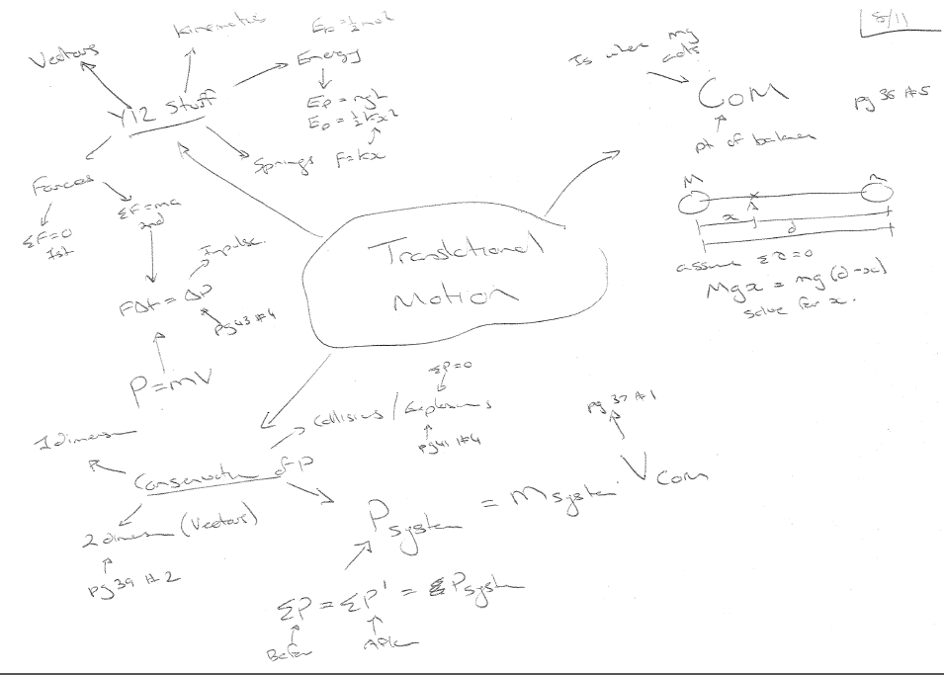

TASK B ~ EXPLAIN AND UNDERSTANDING PHYSICS DIAGRAMS MAKES FOR EXCELLENT REVISION!

**Be familiar with the COMMON DIAGRAMS and GRAPHS in this unit:**

1. Diagram used for centre of mass (CoM).

* The centre of the beam, “A” is not the centre of mass, “B” unless both large masses (left and right) are equal.
* “C” is the distance between the centres of each mass.
* The equation  can be used to find the location of the CoM, x.
* Which ever mass you use for m1 is where x starts at.
* If a force is acted at the CoM there will be no torque and the entire mass will move without rotating.
* If a force is acted on at the centre of the beam (or any place not at the CoM) there will be a torque with with d being the distance between the force and the CoM.

2. A 2-dimentional conservation of momentum situation (air hockey or ice usually).

* No friction so that no external forces so that the law of conservation of momentum can be used.
* All 3 arrows, “A”, “B” and “C”, must be momentums – not speeds – because they fit together in the vector diagram so that “B” and “C” make “A” and momentum is conserved.
* The vertical component of B is equal and opposite to C’s.
* And the horizontal component of B and C together make A.
* If the time of contact is known then the impulse  or the force of collision can be found.

3. Graph of Force vs time for impulse:

* “A” is force in Newtons.
* “B” is time in seconds.
* The area under any line is impulse, Δρ because of the formula.
* Each area, “C” and “D”, would be equal (assuming the object travels at the same speed before collision)
* The 2 curves on this graph are a comparison of a collision with double the time but half the maximum force.
* This is used to explain why crumple-zones in cars are used (or helmets).

4. A conical pendulum with a free-body force diagram AND a vector triangle force diagram.

* “A” is the weight force (straight down).
* “B” is the centripetal force (or net force) straight to the centre of the circle (horizontal).
* “C” is the tension up the string.
* All 3 forces can be redrawn as a vector triangle, “D” with the same angle between weight and tension as in the original diagram.
* The vector triangle can be used to make the equation  which is NOT given on the exam.
* This can be rearranged to give  to find the tangential velocity of the mass or the radius of the horizontal circle.

5. A banked corner diagram that uses the same idea as #4.

* “A” is the weight force (down).
* “B” is the centripetal force OR the net force (to the centre of the corner) horizontal.
* “C” is the support or reaction force 90° to the surface of the ramp.
* “D” is the vector triangle that has the same angle of the ramp between weight and reaction force.
* The same equation  can be used to find the maximum speed around the corner.
* Usually there is ice or water on road so that friction does not “mess up” the force triangle.

6 and 7. Both vertical circle force diagrams.

In both diagrams:

* “A” is the centripetal force as plane enters and leaves loop (to centre of circle)
* “B” is the weight force as plane enters and leaves loop (down).
* “C” is the top of the loop where both weight and centripetal force are downwards.
* “D” is the tangent velocity at the top and “E” is the tangent velocity entering and leaving.
* From tangential velocity arrows it looks like we are assuming constant speed.

In diagram #6:

* Since centripetal force = weight force then the pilot will feel 2g’s entering the loop but will feel 0g’s (weightless) at the top of the loop.
* This means they are travelling at the minimum speed around the loop.
* As they cross the top of the loop they will be in freefall, thus no net force between their body and their seat.
* The equation can be used to make  which gives: to find the minimum velocity to go around the loop

In diagram #7

* Centripetal force looks twice as large as weight force – thus they are traveling much faster than the minimum speed.
* As the pilot enters and leaves the loop they will feel 3g’s.
* As the pilot crosses the top they will feel -1g which is like regular gravity but upwards.
* The equation can be used to make  which gives: to find the velocity required for negative 1g at the top of the loop

**TASK C: NCEA Translational Motion application based questions**

|  |  |  |  |  |
| --- | --- | --- | --- | --- |
| ONE (a) | **SHOW CoM 44cm to the stacked trolleys:** hence 132cm is split on a 2:1 ratio 88:44 with the 44cm closest to the stacked trolleys | 2 Correct working shown (can be diagrammatic). |  |  |
| (b) | **SHOW momentum = 0.11kgms-1:**  The only moving object is the single trolley hence its momentum is the total momentum which is the momentum of the COM, p = mv = 0.5 kg x 0.22 ms-1 | 2Calculation performed to show that the total momentum is 0.11kg ms-1. | *1 Statement that total momentum held by trolley 1 before collision but no clear link to COM.* | *1Correct answer linking total momentum and COM momentum.* |
| (c) | Pafter = 0.11kg ms-1 | 1Correct answer. |  |  |
| (d) | vCoM = Pafter/mtotal = 0.11kg ms-1 ÷ 1.5kg  = 0.0733333 ms-1 | 2Correct answer. |  |  |
| Significant figures | 12 s.f. |  |  |
| (e) | **SHOW each momentum:**  Plarge = mv =0.005 kg x 003 ms-1  = 15 x 10-5 kgms-1 = 1.5 x 10-4 kgms-1  Psmall = mv =0.002 kg x 010 ms-1  = 20 x 10-5 kgms-1 = 2.0 x 10-4 kgms-1 | 2Correct answer. |  |  |
| (f)  Psmall = 2.0 x 10-4 kgms-1  Plarge = 1.5 x 10-4 kgms-1  Ptotal |  | 1Correct arrow directions and labels. |  |  |
| ONE  (g) |  |  | 2calculation of vCoM total without use of vector nature of momentum | *2correct calculation of vCoM* |

|  |  |  |  |  |
| --- | --- | --- | --- | --- |
| TWO (a) | Disc has lost speed therefore lost KE  Therefore collision is **inelastic** | **inelastic** | correct reason |  |
| (b) | the disc has an outside force on it so momentum is not conserved | correct reason |  |  |
| (c) | Δp= pf – pi = 0.225(-0.47 - 0.53) = **-0.225** **≈**  **-0.23 kgms-1** Δp is to the **LEFT** | correct **size** | *correct size and direction* |  |
| (d) | F = Δp/ Δt = -0.225/0.12 = **-1.875** **≈ -1.9 N**  **1.9 N to LEFT** | correct **size** | *correct size and direction* |  |
| (e) | **1.875** **≈ 1.9 N** **to RIGHT** | correct **size** | *correct size and direction* |  |
| (f) | Δv = 2 x (0.4cos 300) = **0.6928…≈** **0.69 ms-1** to the **LEFT** (or West)  vf  -vi  Δv | correctly labelled vector **diagram**. | correctly labelled vector diagram. correct **size** | *correctly labelled vector diagram. correct size and direction* |
| TWO  (g) | 350  This shows the change in momentum of the black puck. Δp = 0.068… kgms-1 at 35.85…0  360  Thechange in momentum of  the white puck is equal and opposite.  . Δp = 0.068 kgms-1 at 360  velocity of black puck is **0.30 ms-1 at 360** | correct **diagram** | Correct **calculation** of momentum | correctly labelled vector diagram. correct **size and direction** |

0.0715

3. (a) p initial = p final (vectors)

P2 final

40

50

magnitudes

p1 initial = 0.065 x 1.8 = 0.117 kg ms-1

0.117

p1 final = 0.065 x 1.1 = 0.0715 kg ms-1

p2 final = ?

Using Pythagoras. (p2 final)2 + 0.07152 = 0.1172

(P2 final)2 = 0.0137 - 0.00511 = 0.00859

p2 final = 0.0927 kg ms-1

v = p/m = 0.0927/0.065 = 1.43 ms-1

(b) KE (1.before) = ½ mv2 = ½ x .065 x 1.82 = 0.105 J

KE (1.after) = ½ mv2 = ½ x .065 x 1.12 = 0.0393 J

KE (2.after) = ½ mv2 = ½ x .065 x 1.432 = 0.0665 J

KE (total after) = 0.0393 + 0.0665 = 0.106 J

So energy is not lost so the collision is elastic.

**NCEA Gravitational application based question**

|  |  |  |  |
| --- | --- | --- | --- |
| ONE  (a) |  | 2 All working correct. |  |
| (b) | Towards the centre of Venus | 1 Centre |  |
| (c) |  |  | 2 Correct working and answer. |
| sf | 3 sf | 1 3 sf |  |

**NCEA Circular Motion application based questions**

|  |  |  |  |
| --- | --- | --- | --- |
| TWO  (a) |  | 1. Forces drawn in but no labels | 1. Both forces correctly drawn and labelled including reaction at right angles to slope |
| (b) | The horizontal component of the reaction force provides the necessary centripetal force to create the circular motion | 1. idea of centripetal force linked to another force | 1. Correct answer or labelled diagram |

|  |  |  |  |  |
| --- | --- | --- | --- | --- |
| (c) | FW = 9.81 x 82.3 = 807 N  FRvert  FRhoriz  **58.2°**  FRvert = FW = 807 N  FR = = = 1530 N | 2 correct answer for Fw / FRvert | 2 correct answer for FRvert  some attempt at finding FR | 2 correct working and answer |
| (d) | FRhoriz = 807**.**…tan58.2°  = 1300 N | 2 correct working and answer |  |  |
| (e) | FC = FRhoriz = 1301**…** N    = 11.2 ms-1 | *1* Correct to 3 sig figs | Correct working except forgot to √ | 2 correct working and answer |
| (f) | She would slide down the slope to the inside of the turn. This is because she no longer has vertical equilibrium as FRhoriz is lower (from lower FC needed now to turn) so FR is lower so FRvert is less than FW |  | 1 Slide down to the inside | 1 Succinct and clear answer |
|  |  |  |  |  |

|  |  |  |  |  |
| --- | --- | --- | --- | --- |
| THREE  (a) | Any object moving in a circular path must have a net force on it, directed towards the centre in order for it to maintian that circular path. | 1Correct answer |  |  |
| (b) |  |  | 2Correct answer |  |
| (c)  Tension  Fw  Fnet  70o |  |  | 2 Incorrect answer showing some appropriate reasoning involving vector arrangement of forces (e.g. vector triangle is a closed one) | 2Correct answer, must show use of vector forces and appropriate trigonometric relationship. |